 |  | One Big Family
Native AMerican Voices |  | 50 minutes

This lesson allows students to practice vocabulary about family relationships and to apply their personal experiences to the artifacts in the Native American Voices gallery.

Vocabulary List

- Family Members: brother, sister, mother, father, cousin, uncle, aunt, grandmother, grandfather, son, daughter, child
- Adjectives: old, young, large, thin, tall, short, handsome/beautiful, ugly
- Tradition: identity, art, festival, belief, clan, culture, custom, value, religion
- Social Roles: warrior, artisan, leader, healer, storyteller, cook, friend, mentor

The Museum Visit

Group Discussion (5 minutes)
Gather around an object in the Native American Voices gallery. Discuss how the artifact relates to lineage and tradition.
Small Group Work (15 minutes)
Divide the class into four groups and have each gather around one of the touch-screen pillars in the gallery. As they explore the interview content, they should gain an understanding of the types of lineages and traditions that are expressed in Native American Culture. Ask the students to record five important words about family, lineage, or tradition from the interviews.

Object Exploration (10 minutes)
Ask the students to examine the objects in the cases along the perimeter of the gallery. Working in pairs, and using some of the words from the previous exercise, select an object and answer the following questions:
- Who would have owned/used the object?
- Who made it for them? Who taught them how to use it?
- What would happen to the object after the owner’s death?

Student Sharing (10 minutes)
Bring the class together around the fire and ask volunteers to share their objects and the stories they have discovered about how they were made, used, and passed down the generations.

recommended objects

Native American Voices
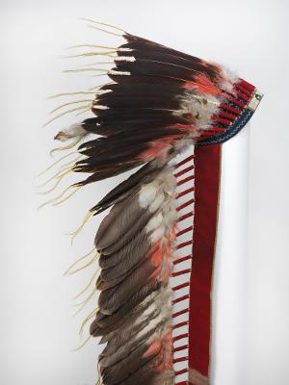

War Bonnet (31-23-142)

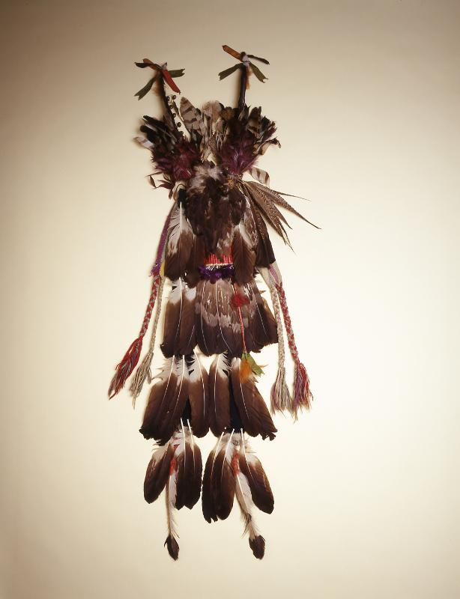

Dance Bustle (45-15-537)

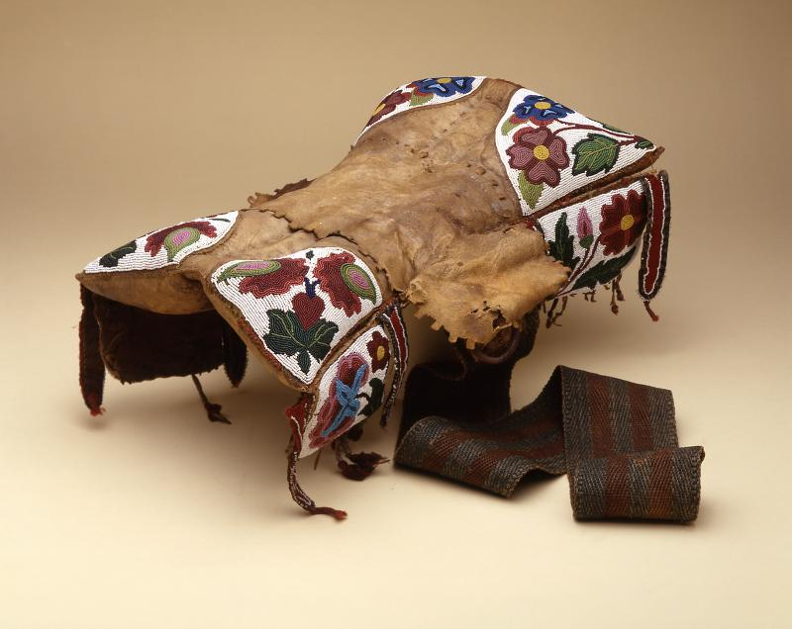

Saddle (81-28-1)

Post-Visit Activities

Who’s In Your Tree?
Using the vocabulary covered in class, create a family tree based on your own family. Try to make it as extensive as possible.

Writing Assignment
Describe an object that you own that has been passed down from an older family member. Compare and contrast your object with an artifact from the Native American Voices gallery. What does your object mean to you? What might an archaeologist discover about you and your family through the object?

Questions?
Ready to schedule a visit?
Contact Penn Museum’s Academic Engagement Department at
classuse@pennmuseum.org

recommended objects

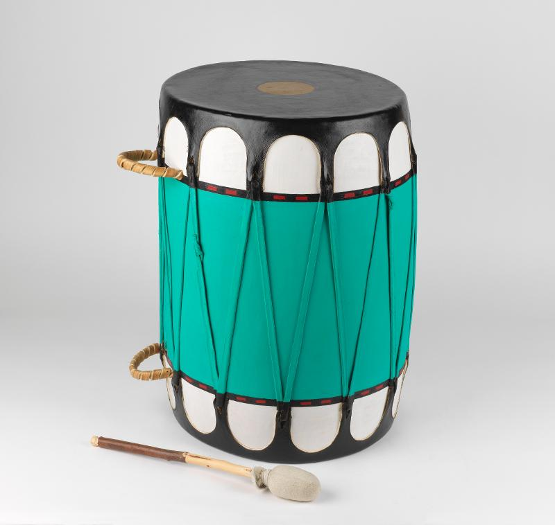

Drum (99-9-1A)

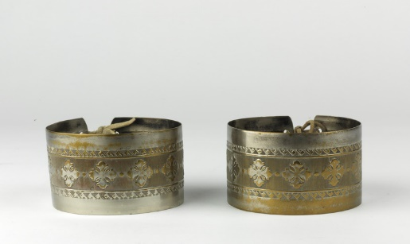

Arm Bands (45-15-682A)

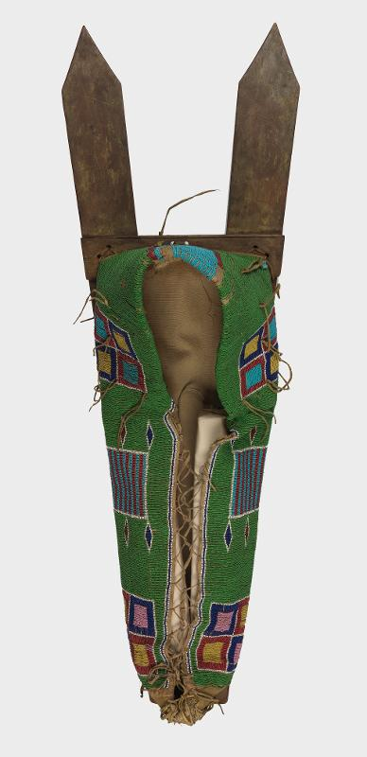

Cradle Board (29-48-19)

